BODMAS
Pearson Edexcel - Tuesday 11 June 2019 - Paper 3 (Calculator) Higher Tier
1.
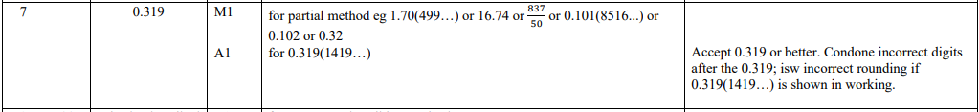
Pearson Edexcel - Specimen Papers Set 2 - Paper 1 (Non-Calculator) Higher Tier
2.
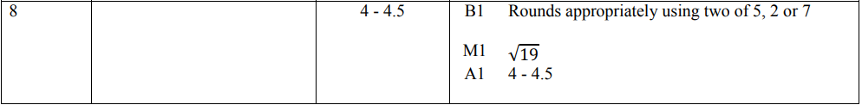
Pearson Edexcel - Specimen Papers Set 1 - Paper 2 (Calculator) Higher Tier
3.
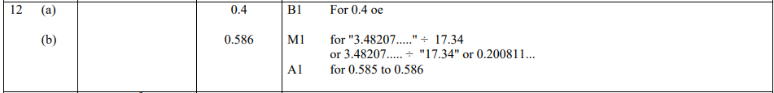
Pearson Edexcel - Monday 7 June 2010 - Paper 3 (Non-Calculator) Higher Tier
4.
OCR GSCE – Tuesday 12 June 2018 – Paper 6 (Calculator) Higher Tier
5.
